Acoustic emission analysis on fracturing experiments performed on samples Newberry-1 and Newberry-4
Newberry-1: A transversal fracture (perpendicular to the fracturing fluid flow) occurred in a plane located between probes 8-2-6 and probe 4. The video shows events in these probes but also events in all the other probes with similar intensity (see color coding). Therefore, there is no correlation between the fracturing process and the events captured by the array of 8 probes and triangulation to map the fracture in real time is not possible.
Newberry-4: A longitudinal fracture (nearly parallel to the fracturing fluid flow) extended 1/3 of the length of the sample from the top (where fracturing fluid is injected). However, events in the video were captured by probe #3 (the furthest probe from the top). This lack of correlation between where the fractured occurred and the probes that detected the acoustic emission (events) is obvious.
Solution: The acoustic research group suggests a software update and a complete calibration of the system with a known source of noise before applying the acoustic sensor array to map fracture networks in real time.
Budget: $30K

Newberry-4 (fracture circled) Newberry-1 (fracture near the top circled)
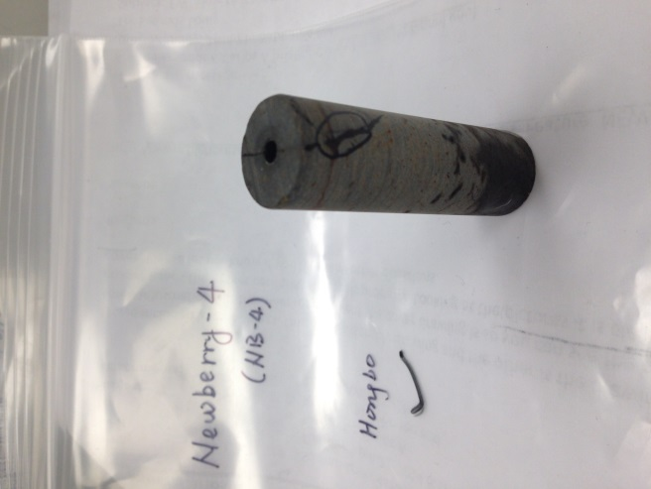
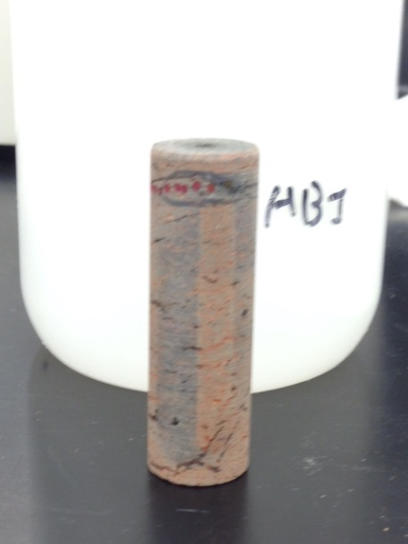
Fracturing
Fluid Flow
Fracturing
Fluid Flow

